 | Dealing with rural water customers in financial difficulty
12 July 2021 | Summary Report
This report has been compiled by:
Jeanette Gellard and Kerri Muller
Innovative Influences & Kerri Muller NRM Pty Ltd

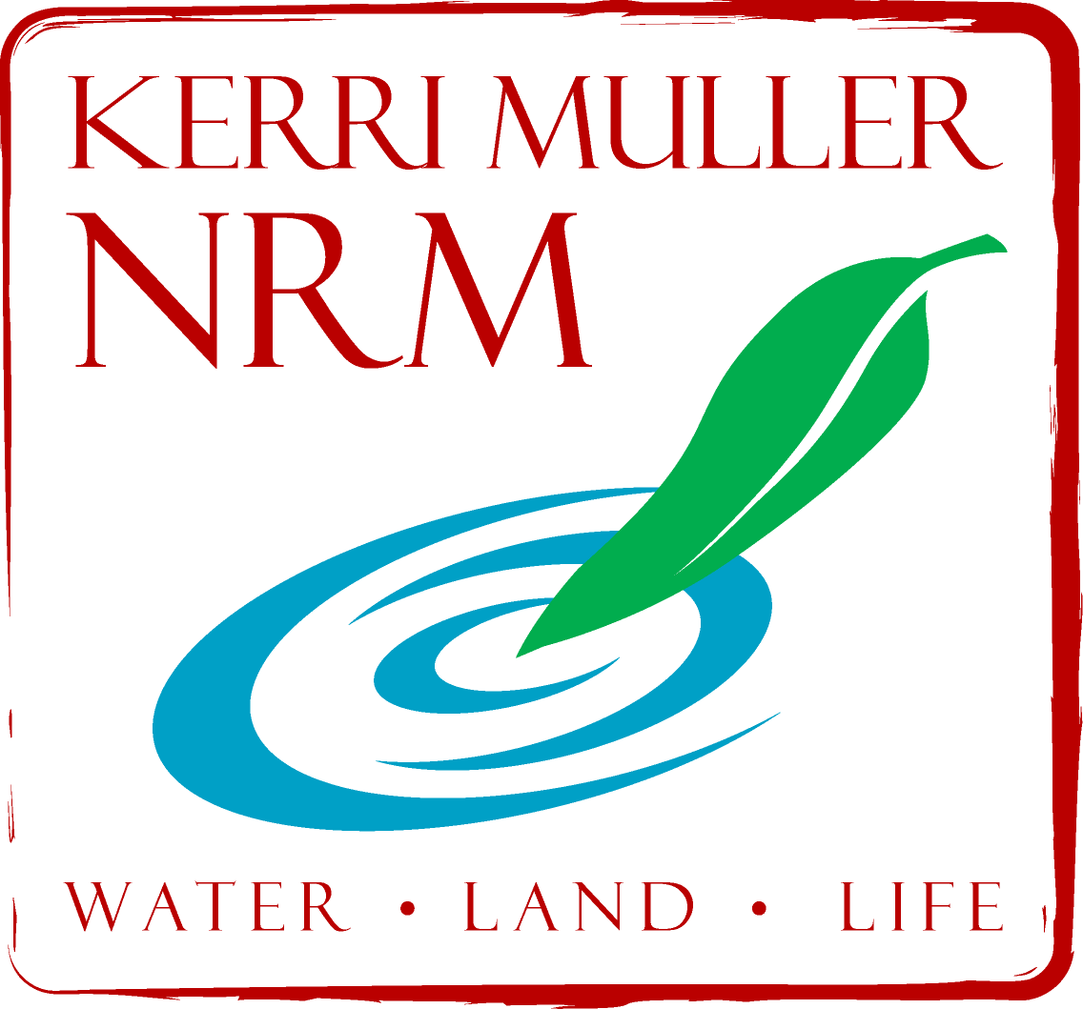

Kerri Muller NRM Pty Ltd & Innovative Influences
All rights reserved; these materials are copyright. No part may be reproduced or copied in any way, form or by any means without prior permission.

Table of Contents
Project Objective 2
Background 2
Project Approach 3
What project success would look like 4
Contextual Information 4
Local Government 4
Rural Financial Counsellor Concerns 6
Training and Capacity Building 6
Capacity Building Tools 7
Financial Hardship Policy (Draft) 7
Financial Hardship FAQ 7
Website Wording Example 7
Rates notice wording example 7
Correspondence templates 7
Hardship Assessment Tool 8
Payment Arrangement Calculator 8
Referral list for Financial Counsellors 8
Referral list for Community Services 8
Concessions information 8
Mortgagee Contacts 8
Training Providers 8
Out of scope hardship issues identified: 8
Key Findings 9
Future Opportunities 10
Appendix A: List of reports for DSCI Supporting Regional Customers in Financial Difficulty (SRCiFD) Project at March 2018 12
Appendix B: M&I Water Retailers Interview Questions 13
Appendix C: Rate Professionals SA Conference Presentation 14
Attachment D: Workshop notes from the Revenue Professionals Conference 17
Attachment E: South Australian Financial Counselling Services 21
Appendix F: Case Study 25

Project Objective
This project aims to:
- Educate retailers on the role of financial counsellors, and
- Develop a coordinated approach to customer service provision for water retailers and organisations who offer financial counselling

Background
Some South Australians receive water and/or sewerage services from their local Council or a private operator other than the main provider, SA Water. These water retailers provide smaller-scale water and/or sewerage services than SA Water, including:
- drinking water for local communities;
- sewerage services though Council operated Community Wastewater Management Schemes;
- small recycled or reuse water schemes.
There are currently over 70 local councils and small private operators providing drinking water services to approximately 5,700 customers and sewerage services to approximately 91,000 customers in South Australia. Councils are subject to a range of competing needs in terms of regularly providing water to industrial and residential consumers, whilst maintaining environmental and water treatment assets such as constructed wetlands and local waterways. Councils are also constrained by limited infrastructure, such as pipelines, to deliver water to as many consumers and areas of their districts as they would like, whether they be irrigators, industrial or domestic users. Environmental factors such as periods of low rainfall, sediment in source water reducing capacity to treat stormwater or algal growth can also limit Councils’ capacity to deliver water.
A Water Retail Code is in place for minor and intermediate retailers, which offers many of the same consumer protections afforded to SA Water’s customers. Specifically, in hardship cases, a residential customer experiencing payment difficulty must be provided with information about: the retailer’s flexible payment arrangements; the retailer’s residential customer hardship policy; government concessions; and independent financial and other relevant counselling services.
In 2016, the South Australian Financial Counsellors Association (SAFCA) undertook a survey of customers and found that generally, most customers of small and intermediate water and sewerage providers were happy with the services they receive. Of the residential customers surveyed, 85% of drinking water and 94% of sewerage services consumers expressed satisfaction. SAFCA did raise concerns about the capacity of service providers to apply the Hardship Policy as required by the Water Industry Act 2012 in complex and difficult circumstances and they recommended building the capacity of service providers to further assist customers who are in financial difficulty. In addition, the survey found:
- 20% of water customers and 12% of sewer customers reported having financial difficulty paying a bill.
- Of these, around 50% of water customers felt their provider was helpful. Customers were offered either an extension of time to pay or a payment plan.
- 80% of sewer customers felt their provider was helpful. Customers were offered either an extension of time to pay (30%) or a payment plan (70%).
- Most customers (83% water and 79% sewer) identified their payment difficulty as a temporary issue.
We understand there are many causes for financial difficulty, which can include; unemployment (or under-employment); illness; relationship breakdown; low income or poverty; and exploitive or unfair financial products.
Financial counsellors have an important role in providing information, support and advocacy to assist people in financial difficulty. Financial counsellors can provide clients with the following support.
- Understanding which debts are priorities
- Advocacy e.g. Credit Code hardship variation, reduce/defer/waive payments, grants or concessions, external dispute resolution
- Developing a money plan/workable budget
- Information e.g. debt collection, consumer rights
- Support (clients are often under emotional stress)
Working in community organisations, their services are free, independent and confidential.

Project Approach
Stage 1: Establish Capacity Building Priorities & Performance (early-mid 2018).
The first suite of tasks will involve a refinement of the project approach and identification of capacity building priorities. This will include;
- Further defining the project scope with DSCI representatives
- Collating relevant background information, research findings and water consumer data
- Engaging and consulting with policy makers, retailers and customers to identify current approaches and application of policy in hardship situations, awareness of financial counselling services
- Engage and consult with Financial Counsellors to identify and understand existing services and their utilisation, current understanding of retailers & customers
- Assess the current status of retailers, customers and financial counsellors interactions and their goals for improvement
Stage 2: Design Capacity Building Process (mid-June 2018).
At the heart of capacity building are resources and activities designed to advance an organisation’s ability to deliver programs, as well as adapt, expand and innovate. Assessment results are used to develop action plan priorities and goals and measure progress. This stage of the project will focus on:
- Identifying gaps in capacity at individual, organisation and systems levels
- Using co-design principles to identify the philosophies and components of a coordinated approach between retailers and organisations providing financial counselling services.
- Design the capacity building approach for retailers and identify techniques to be used i.e. workshops, resource packs, training, information,
Stage 3: Implementation and Building Coordinated Approaches (mid 2018 to mid 2019).
- Delivery of activities that build capacity of retailers across South Australia at individual, organisational and systems levels
- Implement co-designed approach to improving coordination between retailers and organisations providing financial counselling services.
- It is anticipated that activities and approaches will be replicated delivered in multiple locations (in-person and online) to service the needs of retailers
Stage 4: Evaluation & Reporting (mid to late 2019).
The evaluation and reporting phase will:
- Document the project methods, engagement outcomes and results
- Describe particular issues arising for consumers, retailers and financial counsellors
- Evaluate both project process and outcomes.

What project success would look like
- SACOSS, SAFCA and DSCI (and other stakeholders) would have a better understanding of the characteristics of the minor and intermediate water retailers
- Retailers would be provided with a summary of Financial Counselling Services available in regional and rural South Australia (state based and national.)
- A collection of Retailer Case studies would be prepared and distributed including exemplars of (M&I Water Retailers & SA Water and other utility providers) active referrals, staff training, strong connections/relationships
- A capacity building program for retailers would be designed and delivered enabling improvement in services and better assistance for people in financial difficulty
- The next steps for ongoing support and maintenance of capacity with retailers to deal with customers in financial difficulty once this project has finished would be identified
- Future projects for CARP would also be identified
- The impact of the project would be evaluated

Contextual Information
- Large gap in knowledge about M&I Water Retailers and how they implement hardship provisions
- Exemplars – SA Water, AGL, Origin
- Training is needed for retail staff on how to recognise customers that are experiencing hardship – definitions, trigger works, referral scripts
- Consider variations in capacity building tools and techniques between large well-resourced councils and small regional councils
- ESCOSA – Regulator – review underway
- South Australia is covered by a number Financial Counselling Services (FCS) (Attachment E)
- Many FCS are based in regional towns and provide outreach visiting services to other locations e.g. Pt Augusta, Murray Bridge, Pt. Pirie, Whyalla, Mt. Gambier, Pt. Lincoln
- Waiting times to access FCS various across services
- National Debt Hotline (operated by Salvation Army) is a good first port of call

Local Government
- Some Local Governments are retailers of potable and/or recycled water but most that are do not sell potable water to service customers via sewage schemes (e.g. CWMS = community water management scheme).
- Retail customers for treated water tend to be commercial or other government agencies e.g. Hill Grove Mine for Mt. Barker Council, open space irrigation for City of Onkaparinga.
- Wattle Range Council and Northern Areas Council give away treated water to community groups for fundraising activities e.g. growing Lucerne.
- The mechanisms of Local Government billing mean that typically one notice is sent to a customer that includes rates, sewage, water and other service charges. In most instances Council rates notices do not differentiate between rates debt and other debt. This means that Councils cannot distinguish what part/s of their service provision are exacerbating customers’ hardship (e.g. high recovery costs for installing new sewage infrastructure vs. rates (typically the greatest cost on the bill) vs. cost of providing potable/non-potable water).
- Information about the existence of hardship provisions is often provided on rates notices, however, it is not always obvious and mainly directs people to a Hardship Policy on the respective Council’s website.
- There is a significant range in the quantity and quality of hardship information, resources and referral strategies between councils – Exemplars include Coorong Council, City of Onkaparinga.
- The attitudes of leadership within Councils has an impact on the approach that is taken to supporting customers in financial hardship. The impact can be positive or negative.
- Councils do attempt to identify customers with short-term vs. long-term financial hardship and some have different strategies for rates customers with long-term hardship (e.g. looking at options for selling their property to pay rates debts).
- Legislative requirements (Development Act 1993) regarding priority allocation of monies against outstanding amounts dictate how Local Governments apply part payments to the combined rates and services bill. When a rates notice is overdue, fines and interest are applied but customers may be able apply to have the fine removed once a payment plan has been developed.
- Payment plans will always be accepted at any time during the process and no Council (to-date) has had a minimum payment policy.
- Council staff interviewed to-date have a compassionate approach to working with customers experiencing financial difficulty, offering assistance to those that make any form of contact.
- Regional Councils often have one person or a small team managing accounts.
- Council staff to-date appear to be aware of and are providing Hardship Policy information in line with legislative requirements or are in the process of developing a Hardship Policy.
- Procedures for contacting or referrals to financial counsellors vary across the Councils, ranging from a lack of awareness of financial counselling service to Council staff having established relationships with individual financial counsellors and regional strategies in place).
- Knowledge of the National Debt Line 1800 phone number is limited across Councils but is used more and seen as more valuable in remote Council areas with smaller populations where customer anonymity is an issue.
- Wattle Range Council is being proactive with industry sectors who are experiencing downturns (e.g. dairy industry). Offering hardship provision information in a targeted manner and putting in place temporary measures i.e. no interest charges.
- Coorong Council is proactive in community capacity building, especially through their suicide prevention program called ‘Conversations matter”. Teabags with local counsellors’ business cards attached are provided at Council offices, the idea being for people to grab a tea bag and have a chat with someone who might be doing it tough.
- Building an increased water customer base is a future strategy for some Councils who have ‘excess’ water, and this could impact on the number of hardship situations depending on how these schemes are funded (e.g. community pipelines, private infrastructure).
- Some Councils that are selling treated water have a few, large commercial customers that fund infrastructure construction and maintenance cost-recovery. If these contracts cease, then costs to rates customers and residential water customers could increase.
- Wastewater management and infrastructure costs are potentially a much greater financial issue than the water retail side of council business (see Out of scope hardship issues identified).

Rural Financial Counsellor Concerns
- Most Councils will negotiate payment arrangements until there has been two years without payment and then court action may occur.
- Whyalla and Cowell Councils have excellent processes, other entities are not performing as well.
- CentaCare interested in increasing awareness of their services in rural areas but their area is 86% of SA by area and they do not have the resources to go out to people.
- Regional access for face-to-face meetings can be difficult, often arranged for when clients are coming into Whyalla for shopping, medical appointments etc.
- Can be wait lists for new clients.
- Counselling can be done via skype appointments
- If the matter is urgent, then the National Debt Hotline is excellent, if client prefers to be anonymous and/or concerned about church branding.
- Can provide brochures and pdf of National Debt Hotline number for Councils. Can also provide links to on-line budgeting services.
- Research and development need to be done into how best to deliver counselling services in rural and remote areas and build resilience within communities.
- Offered to come to regional meeting of Council Finance Officers to give training in how to identify hardship and some real-life experiences.
- Important to understand that there is often shame and embarrassment associated with hardship – some people have low financial literacy and get into places that are really hard to get out of.
- Some older people will not eat or heat their homes so they can keep up with bills and avoid embarrassment. Small communities with high chance of recognition.
- Short-term loan lenders (e.g. PayDay Loans) are increasing their presence in rural areas. Very high interest rates (44%) for emergency cash loans. Can be difficult for people to avoid when in hardship and they end up on downward spiral.

Training and Capacity Building
Greatest challenges facing Council Staff?
- Recognising when customers are in hardship
- Knowing how to make consistent assessments of the level of hardship
- Knowing who to refer customers too
- Knowing how to communicate with customers to avoid embarrassment
- Encouraging customers to maintain contact
What resources/training would Council Staff like to have available to them?
- Hardship assessment tool
- List of service providers for referral
- Training on dealing with mental health issues (staff & customers) – Life line training
- Training on dealing with challenging conversations
- Resource kits – hard copy/online
- Financial literacy – how to interpret information provided by financial counsellors (ie profit & loss statements)
- Best practice guidelines
- Consistent frameworks for dealing with hardship
- Scripts to support client communications
Current Training
- Training in dealing with customers in financial difficulties are currently being offered by private providers e.g. Revenue Professionals of SA Association (RPSA Inc.) provide professional development activities in this area.
- RPSA have an annual conference, which has been identified by Councils as an excellent avenue for training around Financial Hardship. Next conference: Feb 2019.
- Senior Financial Managers meet twice a year for networking and professional development, and this has also been identified as a suitable opportunity for training. Next meetings: Nov 2018 and March 2019.
- Sam Forsyth, Financial Counsellor, CentaCare, Whyalla has offered to present personal case studies and training to Eyre Peninsular Regional Councils at one of their regional forums.
- Sharon Blackwell, Financial Counsellor, AC Care, Murray Bridge has been providing training to the Coorong Council.
- On-line training and webinars are the most common and favoured platforms for staff training used by councils in remote/regional areas due to travel costs and time constraints.

Capacity Building Tools
In response to the feedback from Council Staff a range of resources have been developed to support the interactions of Council staff and customers experiencing financial difficulties. An overview of the resources is provided below. These have been incorporated into an excel based Financial Hardship Toolkit that has been distributed to Councils identified as water retailers.

Financial Hardship Policy (Draft)
The Water Industry Act 2012 requires water retailers to develop and apply a Hardship Policy.
A water industry entity must—
(a)adopt a customer hardship policy published by the Minister under this section; or
(b)with the approval of the Commission, adopt such a policy with modifications.
Providing example wording that meets the requirements of the Act and which can be applied by retailers could increase consistency across the sector.

Financial Hardship FAQ
This resource assists retailer staff in providing consistent and accurate responses to common questions.

Website Wording Example
Ensuring that information about Hardship Policies and application procedures can be achieved through retailer websites. Placement of information or links to information on ‘home’ pages can increase accessibility by customers.

Rates notice wording example
Rates notices are one of the most consistent and regular forms of communication between retailers and customers. Including information relating to hardship on these notices needs to be seen as a foundational communication tool.

Correspondence templates
Incorporating references and information regarding hardship policies, provisions and application processes along with contact details for Financial Counselling services needs to be consistent approach in correspondence to customers.

Hardship Assessment Tool
A hardship assessment tool supports staff to make informed and accurate assessments of customer circumstances and their eligibility for hardship provisions to be applied.

Payment Arrangement Calculator
The calculator assists staff to determine affordable and effective payment plans that address arrears along with meeting current usage payments.

Referral list for Financial Counsellors
This resource supports staff to make appropriate referrals.

Referral list for Community Services
This resource supports staff to make appropriate referrals.

Concessions information
This resource supports staff in providing customers with accurate information about concession availability.

Mortgagee Contacts
This resource supports staff to make appropriate referrals.

Training Providers
This resource outlines avenues for professional development and training to support staff in their application of Hardship policies.

Out of scope hardship issues identified:
In our discussions with Council representatives, several important issues regarding water and hardship have been raised that are not within the scope of our current project. Some of these are more urgent and potentially harmful than others regarding alleviating financial and emotional hardship on people living in rural and remote communities:
- Rates are a much greater proportion of the total bill than water charges, but Councils are not able to separate them regarding payment in hardship situations.
- Wastewater is a liability for Councils and difficult to turn into a resource due to high costs of treatment, old distribution infrastructure that needs replacing and the legacy of residential developments occurring in areas with limited infrastructure.
- In coastal communities, old shacks are now permanent residences or rented out for short-term accommodation. In many situations, there is limited infrastructure and the septic systems that are in place are outdated and inadequate to protect human or environmental health.
- Current residents are contending with a legacy of historic, poor development standards.
- Cheaper land that attracts a lower socio-economic community profile often has poor infrastructure – a cycle of hardship and inability to update essential wastewater services/infrastructure ensues and for some people this means living in potentially unhygienic situations for which there is no obvious solution.
  - For example, seaside shacks with inadequate on-site septic tanks need pumping fortnightly. This has a cost of ~$350 per fortnight to do properly, which some people cannot afford and so they pump out to the soil surface in their backyards. Community protocols have developed that minimise social impacts but in some coastal areas the groundwater table rises in winter and thus the soakage capacity of these properties decreases, and septic wastewater has nowhere to go. Councils cannot afford to build the infrastructure without recovering costs but these (largely) low socio-economic communities cannot afford to pay for the infrastructure.
- Increased awareness of how wastewater is treated and managed, and concurrent population growth, in recent decades means that there is an urgent need to upgrade sewage treatment in many areas.
- Costs of connections to SA Water and CWWMS are high and prohibitive for people in low socio-economic areas.
- Market failure results in lack of provision of affordable sewage treatment and take-up of wastewater re-use opportunities at commercial, industrial or residential scales.
- In short, Councils can’t enforce upgrades to systems that comply with current policies because people can’t afford it and Councils are required to recover costs for service provision.
- Some Councils are looking at privatising CWWMS as a means of ensuring compliance with contemporary regulations. This could lead to ‘up-front’ costs and increased on-going costs for consumers in a less forgiving environment for dealing with their hardship.
- Councils have been consulting with their communities on the need and costs of upgrading sewage systems. In some cases, the community are pushing back from equalisation of CWWMS user-pays charges across areas with different ages of infrastructure (cross-subsidization of new infrastructure).
- There is currently a perceived tension from Council’s perspective regarding ESCOSA wanting Councils to be cost-recovering or profit-making but doing so without imposing hardship on communities.
- This presents opportunities for SA in terms of growing rural and regional communities and industries on new wastewater treatment and distribution networks but comes at a large up-front cost that cannot simply be passed to Council rates or water retail customers without causing hardship and stifling innovation.
  - For example, Hill Grove Mine operations at Kanmantoo are likely to cease in 2020, which means Mount Barker District Council will lose their main treated water customer at a time when the population is also increasing to a point that new sewage infrastructure may be needed and more wastewater than the Laratinga Wetlands were built for will be generated. New irrigation industries could be established along the existing pipeline from Mount Barker to Kanmantoo in an area that currently has very limited water availability. State Government investment and policies would probably be required to make such a transition successful.
- Financial literacy across council staff and the broader community was identified as a gap particularly when seen as a key factor in supporting independent living among young people. A few programs supporting young people have been established in urban areas however there are limited offerings in rural and regional areas.

Key Findings
Some Local Governments are retailers of potable and/or recycled water but most that are do not sell potable water to service customers via sewage schemes. Retail customers for treated water tend to be commercial or other government agencies.
Wastewater can be a liability for Councils and difficult to turn into a resource due to high costs of treatment, old distribution infrastructure that needs replacing and the legacy of residential developments occurring in areas with limited infrastructure.
Costs of connections to SA Water and CWWMS are high and prohibitive for people in low socio-economic areas. Market failure results in lack of provision of affordable sewage treatment and take-up of wastewater re-use opportunities at commercial, industrial or residential scales.
Notwithstanding this building an increased water customer base is a future strategy for some Councils who have ‘excess’ water, and this could impact on the number of hardship situations depending on how these schemes are funded (e.g. community pipelines, private infrastructure).
Some Councils are also looking at privatising CWWMS as a means of ensuring compliance with contemporary regulations. This could lead to ‘up-front’ costs and increased on-going costs for consumers in a less forgiving environment for dealing with their hardship.
The way in which service providers integrate and apply the Hardship Policy into their operations varies significantly.
There is a significant range in the quantity and quality of hardship information, resources and referral strategies to financial counselling services between councils. Training is needed for retail staff on how to recognise customers that are experiencing hardship.
There are many examples of actions amongst retailers that collectively demonstrate good practice in this area. The challenge is achieving a consistent approach amongst all retailers.
The attitudes of leadership within Councils has an impact on the approach that is taken to supporting customers in financial hardship. The impact can be positive or negative.
The mechanisms of Local Government billing mean that typically one notice is sent to a customer that includes rates, sewage, water and other service charges. In most instances Council rates notices do not differentiate between rates debt and other debt.
Legislative requirements (Development Act 1993) regarding priority allocation of monies against outstanding amounts dictate how Local Governments apply part payments to the combined rates and services bill.
Most Councils will negotiate payment arrangements until there has been two years without payment and then court action may occur.
Short-term loan lenders (e.g. PayDay Loans) are increasing their presence in rural areas. With very high interest rates (44%) being charged for emergency cash loans it can be a contributing factor to ongoing financial hardship amongst some customers.
The greatest challenges facing Council staff relate to recognising and assessing levels of hardship, communicating with customers and knowing how to refer customers to.
The training needs of Council staff focus on financial literacy, recognising hardship and having challenging conversations. Identified resource requirements include a hardship assessment tool, referral information and scripts to support client communications.
Training in dealing with customers in financial difficulties are currently being offered by private providers and financial counsellors.
On-line training and webinars are the most common and favoured platforms for staff training used by councils in remote/regional areas due to travel costs and time constraints.

Future Opportunities
- ‘Hardship’ training to be incorporated into the Revenue Professionals Association annual conference and Senior Finance Managers network meetings on a regular basis.
- Support Financial Counselling Services of South Australia to develop and deliver training packages for Council staff around financial literacy, recognising hardship and having challenging conversations.
- Further research and development into how best to deliver financial counselling services in rural and remote areas and build resilience within communities will benefit regional water customers experiencing financial difficulty.
- Investigation into extent of old distribution infrastructure and limitations it is placing on adherence with regulatory requirements.
- Exploration of innovative investment approaches to take advantage of opportunities that arise for SA in terms of growing rural and regional communities and industries on new wastewater treatment and distribution networks.

Appendix A: List of reports for DSCI Supporting Regional Customers in Financial Difficulty (SRCiFD) Project at March 2018
- Annual SACOSS Briefing to the Minister for Communities and Social Inclusion: Water Pricing Issues Affecting South Australian Consumers, SACOSS (SA Council of Social Services), June 2017.
- SACOSS Submission to Productivity Commission 2017, National Water Reform, Draft Report – October 2017.
- Minor and intermediate retailers regulatory performance report 2014-15. Essential services commission of SA, June 2016.
- DEWNR (2013). Alinytjara Wilurara Demand and Supply Statement, 2013. SA Department for Environment, Water and Natural Resources.
- DEWNR (2013). SA Arid Lands Demand and Supply Statement, 2013. SA Department for Environment, Water and Natural Resources.
- DEWNR (2015). Kangaroo Island Demand and Supply Statement, 2015. SA Department for Environment, Water and Natural Resources. November 2015.
- DfW (2011). Eyre Peninsula Demand and Supply Statement, April 2011. SA Department for Water.
- DfW (2011). Northern and Yorke Demand and Supply Statement, November 2011. SA Department for Water.
- Better solutions for helping customers with financial difficulty: Energy and Water. A cross-sector approach to supporting vulnerable consumers. SACOSS, January 2016.
- The retail and network exemption framework: Emerging issues for consumers. Report on the growing concern with consumer protection arrangements for exempt consumers. SACOSS, December 2015.
- Restricted Water Customer Research. Prepared by URBIS for SACOSS, October 2017.
- Hardship Policy for Residential Customers, Minister for Communities and Social Inclusion, February 2013.
- Hardship Policy for Residential Customers of Minor and Intermediate Water Retailers, Minister for Communities and Social Inclusion, September 2013.
- South Australian Water and Sewerage Concessions Scheme, Corporate Services, Government of South Australia, July 2017.
- Water Consumers Research Project A Consultation for the South Australian Department of Communities and Social Inclusion. JFA Purple Orange, June 2017.
- Minor and Intermediate Retailers Research and Advocacy Project Report to the Department of Communities and Social Inclusion Water and Sewerage Suppliers in South Australia W. Shirley, South Australian Financial Counsellors Association (SAFCA), November 2016.

Appendix B: M&I Water Retailers Interview Questions
- Who are your water customers? Owner occupiers/landlords/business
- Which staff are responsible for managing overdue accounts?
- What are your processes for managing overdue accounts?
- Do you have any hardship provisions in place for customer accounts?
- What are the hardship provisions? How are these provisions applied?
- Who within the organisation has responsibility for applying hardship provisions?
- Do relevant staff receive any training around the hardship provisions? If yes, what training is provided?
- Have you heard of Financial Counselling Services?
- What can you tell us about the services they provide?
- Have you ever referred customers to any Financial Counselling Service? Is so, how many?
- Would you be interested in receiving training about dealing with customers experiencing financial hardship/Hardship provisions/financial counselling services?
- How could this training be best delivered? Timing? Location?
- Who would attend this training from your organisation?

Appendix C: Rate Professionals SA Conference Presentation
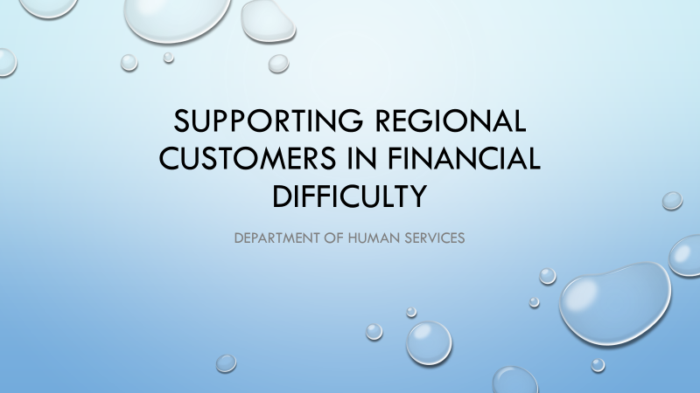
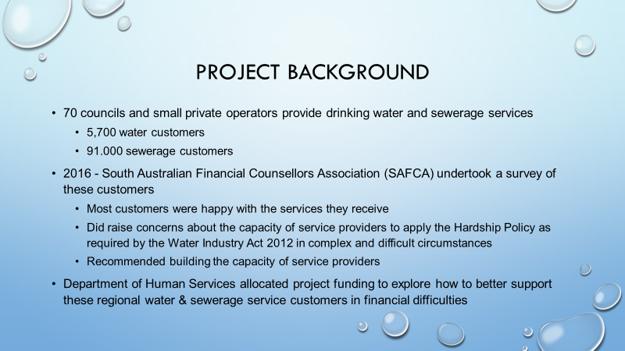

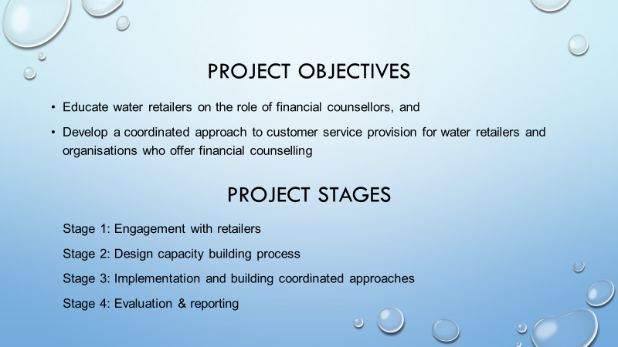
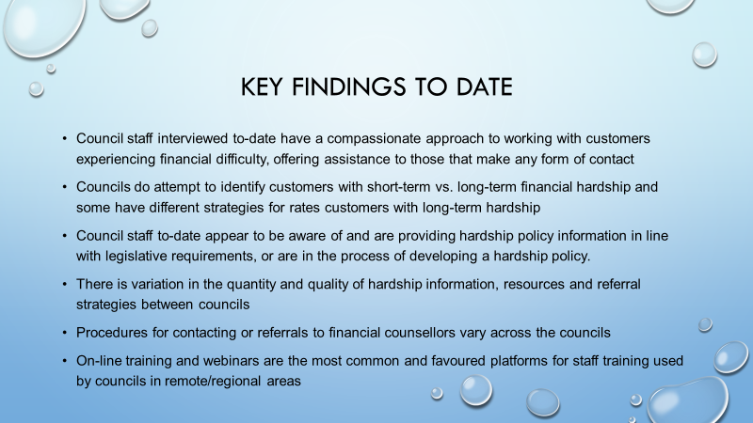
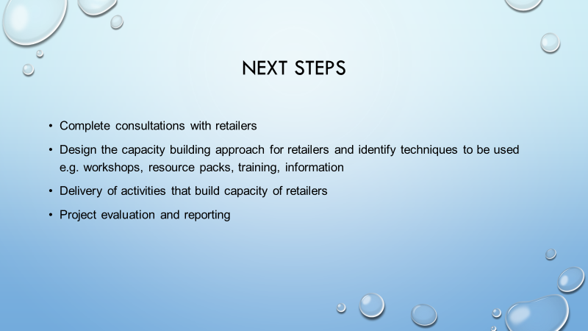

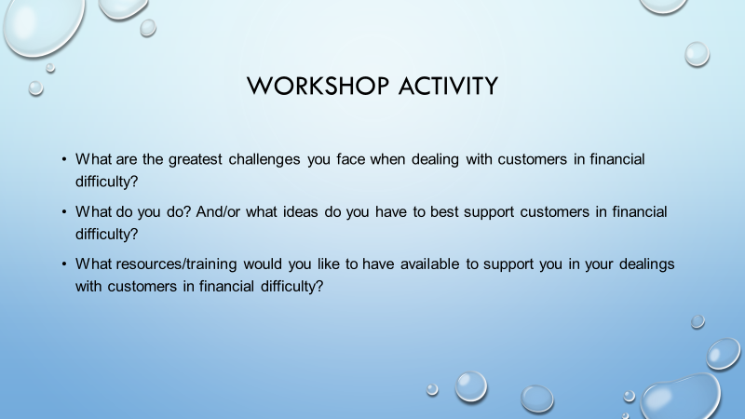
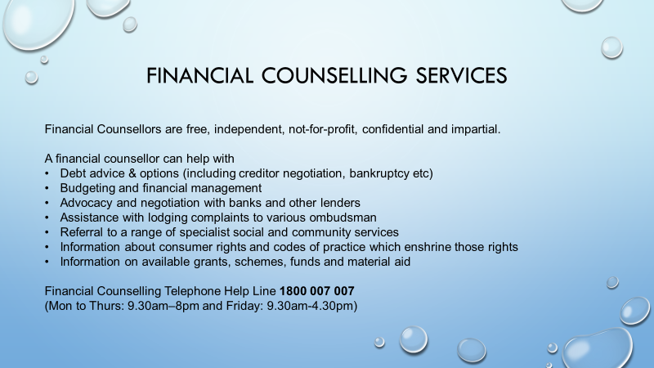

Attachment D: Workshop notes from the Revenue Professionals Conference
Revenue Professionals Conference
8 February 2019
What are the greatest challenges you face when dealing with customers in financial difficulty?
- Working out what is hardship
- Determining level of hardship
- No forward planning by payer
- Have policy but all cases are different
- Assessment process
- More financial counsellors are needed, long wait times
- Customers reluctant to seek financial counselling support – pride/embarrassment/shame
- Confidentiality – don’t judge people
- Most unaware Council have hardship policy even though it is in all literature/correspondence
- We can provide empathy but are not counsellors – they are usually dealing with other personal issues
- Refer to appropriate agency
- Unknown factors (short-term/long term) i.e. if unemployed – they don’t even know
- Customer expectations (concessions – thinking we are like State/Federal government)
- Negotiations – what we need vs what they can afford
- Fear of financial counsellors – don’t want to admit their actual spending
- Making contact in the first place – embarrassment – scared/head in the sand/denial
- Hard to understand their situation when never been in it yourself
- Dealing with customers
- Limited capacity to assist
- Consistent framework?
- Early intervention
- Resources + availability
- Emotions
- Getting them to open-up to their financial position
- Getting them to commit to making a payment – no payment is not a good option fo any-one
- Legal is last resort
- Need to communicate with council to avoid legal
- They need to demonstrate that there is no capacity to pay
- Refer to Salvo’s as only know option for financial counselling
- Linking them up with the professional services they require at the time they engage with council
- Having resources to assess the degree of financial hardship – education
- Support – financial counsellors advising owners of where their financial priorities should be
- Tools to determine ‘real hardship’ vs poor money management
- Negative interactions (tears, abuse, anger)
- Embarrassment
- Making contact – getting correct information or even hearing from the customer
- Attitude/avoidance
- To start with getting them to contact council when they are struggling
- What to say without offending them
- Getting them to go to financial counselling is very difficult. People are proud.
- People who go to financial counselling don’t follow advice. Isn’t what they want to hear.
- If you can’t afford in long term then why do you own property? Sell it! And rent, get rent assistance.
- Communication from customer
- Building trust & relationship with customer
- Making process as easy as possible
- Up to date contact details
- Customers with mental health or medical issues
- Council unable to contact
- Getting debtor to realise issue early i.e. early intervention
- How to deal with family trauma. Understanding debtor problems.
- Debtor understanding their priorities
What do you do? And/or what ideas do you have to best support customers in financial difficulty?
- Offer P/A – if kept for FY – waive fees
- Encourage contact – early – encourage conversation – explain situation – build relationship
- Potential remission of rates
- Explain options – be very clear. Hardship, superannuation, seniors’ postponement, postponement, arrangements
- Ensure staff are trained
- Need a list of financial counsellors to refer to them
- We need them to maintain agreed payment plans
- Its not our role to counsel the rate payer
- Even if payment is deferred for 3 months, they still need to commence payments at the end of that period
- Engage with the and provide as much info as possible on how they can help themselves
- Build good relationships with the customer
- Remit legal fees and late fees ONLY on compassionate grounds – only once payments start coming
- Payment arrangements
- Advise to seek financial counsellors (provide details)
- Encourage to keep in contact
- Exclude from fines and interest – payment extensions
- Listen to the customer (support)
- Free hotline
- Building relationship with the customer – TRUST
- Having the customer enter into a payment arrangement which sees the debt paid in full over the long term and eventually addresses current debt
- Financial calendar, break down payments into week, fortnightly payments making it easier for rate payers to see and realise goals
- Give them the number of the financial counsellor
- Organise payment plans
- Postponement seniors
- Very limited in our capacity to advise people on their situations
- Pay rates etc or sell up as some people are going backwards. Rent – assistance- rent assistance et available but we can’t say this type of thing even if its in their best interest
- Responsibility as a home owner. Take some responsibility to their positions and deal with it. Pay bills! Not fair to ratepayers who are doing the right thing.
- Letter to customer to contact
- Suggest to customer to see financial counsellor
- Refer to financial counsellor
- Try to be sympathetic
- Keep communication lines open
- Depending on circumstances place ‘hold on debt’ for a period
- Intervene early
What resources/training would you like to have available to support you in your dealings with customers in financial difficulty?
- Consistency with Council
- Standard dialogue
- List of service providers of financial counsellors
- Mental health of both ratepayers and staff dealing with issues
- Clear staff process and information easily accessible
- Hardship assessment tool
- LGA to provide tools
- Regular/ongoing
- Difficult customers/debt collection
- Compassion yet stern – how to do?
- Role-play inclusive
- Understanding Mental health
- Resources – package/online
- Training
- Consistent framework
- Counsellors – DHS? Why did they withdraw this service?
- Resource pack
- Referral sheets
- Staff training
- Mental health – customer + staff
- List of financial advisers in the area – to refer rate payer to
- How to interpret Income & Expenditure statements supplied by financial counsellor
- Financial service that is dedicated to local council only. AKA, with our interests in mind as well as the customer – managed by LGA?
- A list of available services per council area
- Awareness of financial counsellors available – especially in regional areas
- Create a best practice guideline manual for administrators
- More opportunity for training courses in regional areas
- Assistance from LGA
- Life line training/difficult/resolution
- More staff on the ground (govt) helping people – mobile – going to houses to talk to people who are struggling
- Understanding what financial counsellors do
- Right questions to ask customer to make them open up
- Determination between short term vs long term hardship
- Contact from financial counsellors to advise what they can offer
Representatives from the following council areas participated in the workshop activity.
South Australia

- Adelaide Hills
- Alexandrina
- Barossa
- Berri Barmera
- Charles Sturt
- Clare
- Elliston
- Gawler
- Grant
- Holdfast Bay
- Kangaroo Island
- Kingston
- Loxton Waikerie
- Mitcham
- Mount Barker
- Mount Gambier
- Mt Remarkable
- Murray Bridge
- Norwood/Payneham/St Peters
- Onkaparinga
- Playford
- Port Adelaide/Enfield
- Prospect
- Pt. Pirie
- Tatiara
- Victor Harbor
- Wattle Range
- West Torrens
- Yankalilla

Interstate
- Queensland Rep
- Canterbury Bankstown NSW Reps
- Campbelltown NSW reps

Attachment E: South Australian Financial Counselling Services

Statewide Services
Telephone Financial Counselling Helpline
Freecall: 1800 007 007
Fax: (08) 8227 0237
Email: fcsupport@aus.salvationarmy.org
http://www.ndh.org.au

Rural Business Services SA (inc financial counselling)
Freecall: 1800 836 211
www.ruralbusinesssupport.org.au

Aboriginal Legal Rights Movement – City
321-325 King William St, Adelaide SA 5000
Tel: 8113 3777
Freecall: 1800 643 222
Email: info@alrm.org.au
www.alrm.org.au

Uniting Communities
10 Pitt St Adelaide SA 5000
Tel: (08) 8202 5180
www.unitingcommunities.org

Uniting Communities
2/2b Morialta Drive,
Smithfield
Tel: 08 8202 5980

Uniting Communities
3/107 Dyson Road,
Christies Beach
South Australia 5165
Tel: 1800 615 677 (choose option 3)

Salvation Army Community Support Services
277 Pirie Street, Adelaide 5000
Tel: (08) 8227 0199

The Magdalene Centre
82 Gilbert St, Adelaide SA 5000
Office Hours: 9 am to 5 pm Mon – Fri
Tel: 1800 759 707

Gambling Help Service
Relationships Australia (SA)
161 Frome Rd, Adelaide 5000
Tel: (08) 8223 4566

Northern Community Legal Service
26 John Street, Salisbury 5108
Tel: (08) 8281 6911

North East Financial Counselling
(a service of Northern Community Legal Service)
Pathway Community Centre
1/249 Milne Road
Modbury North SA 5092
Tel: (08) 8395 8898
Fax: (08) 8265 0881
Mobile: 0415 611 585

UCWB
Uniting Care Wesley Bowden
77 Gibson St Bowden SA 5007
Tel: (08) 8245 7100
Email: ucwb@ucwb.org.au

UCWB
Blair Athol B7 Children’s Centre
5 Marmione Ave,
Blair Athol 5084
Phone 8245 7100

UCWB
Cheltenham Community Centre
62 Stroud St North
Cheltenham 5014
Phone 8245 7100

UCWB
Findon Community Centre
222 Findon Road
Findon 5023
Phone 8245 7100

UCWB
Hamra Centre Library (after hours appointments 6-8pm)
165 Sir Donald Bradman Drive
Hilton 5033
Phone 8416 6228 (phone between 9am-5pm to book appointment)

UCWB
Housing SA Croydon Park
344 Torrens Road
Croydon Park 5008
Phone 8245 7100

UCWB
The Grove Uniting Church
66 Ridley Grove
Woodville Gardens 5012
Phone 8245 7100

UCWB
Westside Lawyers
212 Port Road
Hindmarsh 5007
Phone 8245 7100

UCWB
UCWB Marion branch
730 Marion Road,
Marion 5043
Phone 8245 7100

Munno Para Library(UCW Bowden Outreach Site)
Munno Para Shopping Centre, Smithfield 5114
Tel: (08) 8245 7100 (UCW Bowden)
Fax: (08) 8346 7336

Para Hills Library (UCW Bowden Outreach Site )
Wilkinson Road, Para Hills SA
Tel: (08) 8245 7100 ( UCW Bowden )
Fax: (08) 8346 7336

UCWB
Elizabeth Centrelink (UCW Bowden outreach Site)
7 Langford Drive
Elizabeth SA 5112
Tel: (08) 8245 7100 (UCW Bowden) Fax: (08) 8346 7336

Anglicare
The Mission at Elizabeth
91 Elizabeth Way, Elizabeth
Freecall: 1800 759 707

Anglicare SA
6 Church St Salisbury SA
Freecall: 1800 759 707

Anglicare SA
Outer Southern Hub
Beach Rd
Christies Beach
Tel: 1800 759 707

Lutheran Community Care
309 Prospect Road, Blair Athol SA 5084
Tel: (08) 8269 9300
Fax: (08) 8269 9345

Lutheran Community Care
22 Heytesbury Rd Daveron Park 5113 SA
Tel: (08) 7070 6711
Fax: (08) 8287 0120

Lutheran Community Care
Mount Barker and Aldgate
appts. through Tel: (08) 8269 9300

Lutheran Community Care
Nurioopta
26 Second Street, Nurioopta 5355
Tel: (08) 8562 2688 Fax: (08) 8562 2657

UCare Gawler Inc.
10 Tod St, Gawler SA 5118
Tel: (08) 8522 4522
Email: ucare@internode.on.net

Uniting SA
58 Dale St Port Adelaide SA 5015
Tel: (08) 8440 2299
unitingsa.com.au

CareWorks SA & NT
114 Henley Beach Rd. Torrensville 5031
Tel: (08) 8234 5802
Email: admin@cwsa.org.au

Salvation Army Community Support Services
Arndale Regional Office
1-7 Gray Street, Kilkenny 5009
Tel: (08) 8445 2044
Fax: (08) 8268 8177

Overseas Chinese Association of SA
110 Crittenden Road, Findon SA
Tel: (08) 8445 7355
www.lowincomesupportoca.com

FUSA – Flinders University Student Association (Students only)
Plaza Level, Union Building
Flinders University, Bedford Park
Tel: (08) 8201 2371

Marion Salvation Army Community Support Services
155 Sturt Rd (Cnr Sturt and Morphett Rd’s), Seacombe Gardens SA 5047
Tel: 8377 0001

Southern Regional

Lifeline South East (SA)
Also offering Gambling Help Services and outreach to Kingston, Keith and other regions in the South East
5 Mark St, Mount Gambier SA 5290
Tel: (08) 8723 2299
Email: office@lifelinese.com.au

accare
accare Mt Gambier Community Centre
22-24 Ferrers St, Mount Gambier SA 5290
Tel: (08) 8723 0540

accare – Mt Barker outreach
Tel: (08) 8532 6303

accare – Berri
5 Kealley Avenue, Berri
Tel: (08) 8582 2344

accare – Millicent Community Centre
57-59 George St, Millicent SA 5280
Tel: (08) 8733 4720
Eastern Regional (SA)

Gambling Help Services – Riverland and Murraylands
Relationships Australia
Tel: 1800 182 325

accare – Waikerie Community Centre
1 Crush Tce, Waikerie SA 5331
Tel: (08) 8541 2081

Berri Salvation Army
20 Wilson Street
Berri SA 5343
Ph: (08) 8582 3182
Fax: (08) 8582 3538
Freecall: 1800 823 182

accare – Murray Bridge
11-21 Kennett Road, Murray Bridge SA 5253
Tel: (08) 8532 6303
Fax: (08) 8532 1823

Western Regional (SA)

Aboriginal Legal Rights Movement – Port Augusta
12 Church Street, Port Augusta SA 5700
Tel: (08) 8113 3788
Fax: (08) 8642 4650
Freecall: 1800 643 222

Uniting Country SA
60 Florence St Port Pirie SA 5540
Tel: (08) 8633 8600
Email: financialcounselling@ucsa.org.au

Centacare Catholic Country SA
32 Mortlock Tce, Port Lincoln
Tel: (08) 8683 0733
Fax: (08) 8683 0477

Centacare Catholic Country SA
28 Head Street, Whyalla Stuart SA 5608
Tel: (08) 8645 8233

Centacare Catholic Country SA
6 Gibson St, Port Augusta SA 5700
Tel: (08) 8641 2379

Centacare Catholic Country SA
Hutchinson St, Coober Pedy
Tel: (08) 8641 2379

Centacare Catholic Country SA
11 McKenzie St, Ceduna SA
Tel: (08) 8625 3810

AnglicareSA
34-36 Galpin Street Whyalla Stuart SA 5608
Tel: 1800 759 707
Uniting Country SA
60 Florence St Port Pirie SA 5540
Tel: (08) 8633 8600
Email: financialcounselling@ucsa.org.au

The Salvation Army-Community Support Services
Cnr Viscount-Slim Avenue & Scoble Street, Whyalla Norrie SA 5608
Tel: (08) 8645 7101
Fax: (08) 8644 2045

Northern Regional (SA)

Aboriginal Family Support Services – Far North Country Program – Coober Pedy
47 Commercial Road, Pt Augusta SA 5700
Tel: (08) 8640 0907

Uniting Country SA
60 Florence St Port Pirie SA 5540
Tel: (08) 8633 8600
Email: financialcounselling@ucsa.org.au

Appendix F: Case Study

Supporting customers experiencing financial hardship
Local Government Experiences
Introduction
There are currently over 70 local councils and small private operators providing drinking water services to approximately 5,700 customers and sewerage services to approximately 91,000 customers in South Australia.
Concerns have been raised about the capacity of service providers to apply the Hardship Policy as required by the Water Industry Act 2012 in complex and difficult circumstances.
The way in which service providers integrate and apply the Hardship Policy into their operations varies significantly. Revenue Professionals within the local government sector have acknowledged the many challenges faced by provider staff in dealing with customers facing financial difficulty.
Two service providers, City of Playford and Coorong District Council have implemented a range of tools and strategies to deliver positive outcomes for both customers and their staff. Their approaches provide a sound framework for other providers to apply in improving the setor’s capacity to apply Hardship Policies.
Background
A Water Retail Code is in place for minor and intermediate retailers, which offers many of the same consumer protections afforded to SA Water’s customers. Specifically, in hardship cases, a residential customer experiencing payment difficulty must be provided with information about: the retailer’s flexible payment arrangements; the retailer’s residential customer hardship policy; government concessions; and independent financial and other relevant counselling services.
In 2016, the South Australian Financial Counsellors Association (SAFCA) undertook a survey of customers and found that generally, most customers of small and intermediate water and sewerage providers were happy with the services they receive. Of the residential customers surveyed, 85% of drinking water and 94% of sewerage services consumers expressed satisfaction.
The survey also found:
- 20% of water customers and 12% of sewer customers reported having financial difficulty paying a bill.
- Of these, around 50% of water customers felt their provider was helpful. Customers were offered either an extension of time to pay or a payment plan.
- 80% of sewer customers felt their provider was helpful. Customers were offered either an extension of time to pay (30%) or a payment plan (70%).
- The majority of customers (83% water and 79% sewer) identified their payment difficulty as a temporary issue.
Notwithstanding these positive results, it was felt that more could be done to support providers in their dealings with customers.
In 2019, a workshop session at the Revenue Professionals of SA Association Annual Conference asked delegates what the greatest challenges facing staff were when dealing with customers experiencing financial difficulty.
- Recognising when customers are in hardship
- Knowing how to make consistent assessments of the level of hardship
- Knowing who to refer customers too
- Knowing how to communicate with customers to avoid embarrassment
- Encouraging customers to maintain contact
When asked what resources and/or training Council Staff would like to have available to them, the responses included;
- Hardship assessment tool
- List of service providers for referral
- Training on dealing with mental health issues (staff & customers) – Lifeline training
- Training on dealing with challenging conversations
- Resource kits – hard copy/online
- Financial literacy – how to interpret information provided by financial counsellors (ie profit & loss statements)
- Best practice guidelines
- Consistent frameworks for dealing with hardship
- Scripts to support client communications
- Some Councils have been very active in recognising and addressing the above challenges and needs and provide positive examples of actions that can be taken to deliver positive outcomes for both customers and service provider staff.
Coorong Council
Coorong District Council is a local government area in South Australia located between the River Murray and the Limestone Coast region. The district covers mostly rural areas with small townships, including the Murray River, Lake Alexandrina and Lake Albert. The district’s main towns of Meningie, Tailem Bend, Coonalpyn and Tintinara thrive on a blend of farming with its related industry, fishing, commerce and tourism. as well as part of the Coorong National Park.
The council was formed in May 1997 with the amalgamation of the District Council of Coonalpyn Downs, the District Council of Meningie and the District Council of Peake. It is geographically the largest council area in South Australia.
The council seat is at Tailem Bend; the council also operates service centres in Meningie and Tintinara. Council maintain a range of services in keeping with their vision and purpose of Sustainability, Prosperity, Wellbeing and Leadership.
The townships of Tailem Bend, Wellington East, Meningie and Tintinara area all serviced by a Council run CWMS. Septic tank overflows are directed into Council’s CWMS network and generally treated for re-use on gardens and ovals.
After a number of community members died by suicide within a short space of time in 2014/2015, the Council took a leadership role in supporting the community. It held four 'Conversation Matter' suicide prevention forums and discussions in Tailem Bend, Meningie, Peake and Tintinara in late 2015. Council used these forums to work with the community to take a collective approach to improving the health and mental health of the community.
This overarching approach permeated throughout Council’s operations including its approach to dealing with customers experiencing financial difficulties.
Council’s customer service staff were the first contact point for community members, and so an investment in training was made to provide staff with skills in recognising signs of stress and hardship. One of the initiatives to come out of the Conversations Matter forums was the development of tea bag wallet cards #converstionsmatter (Figure 1). These cards encouraged people to invite others to share a cup of tea and conversation about an individual’s wellbeing. These were made available to Council staff for distribution and use.
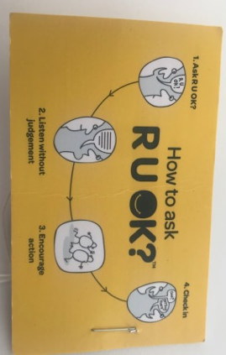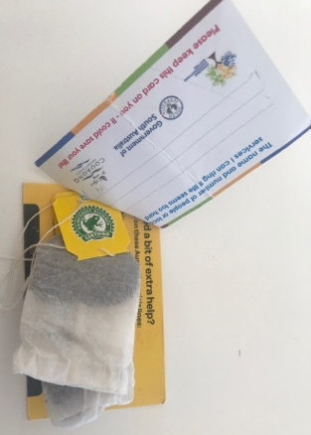
Figure 1: Teabag Wallet Cards
Training was provided to the customer service team by the local Financial Counsellor, Sharon Blackwell. Ms Blackwell covered the role of financial counsellors and the services they provide along with how to recognise signs of stress or hardship. Staff indicated this training was extremely valuable.
Staff were also provided with information resources to provide to customers about the range of services available to them.
Further to this action, Coorong Council changed its documentation to include Financial Counselling service contact details. This included rates notices, rates reminder notices and payment correspondence.
Information about the Council’s Hardship Policy is available on its website (Fig 2) and applications for financial hardship consideration can be made by accessing an application form from the council or downloading it from Council’s website (Fig 3).
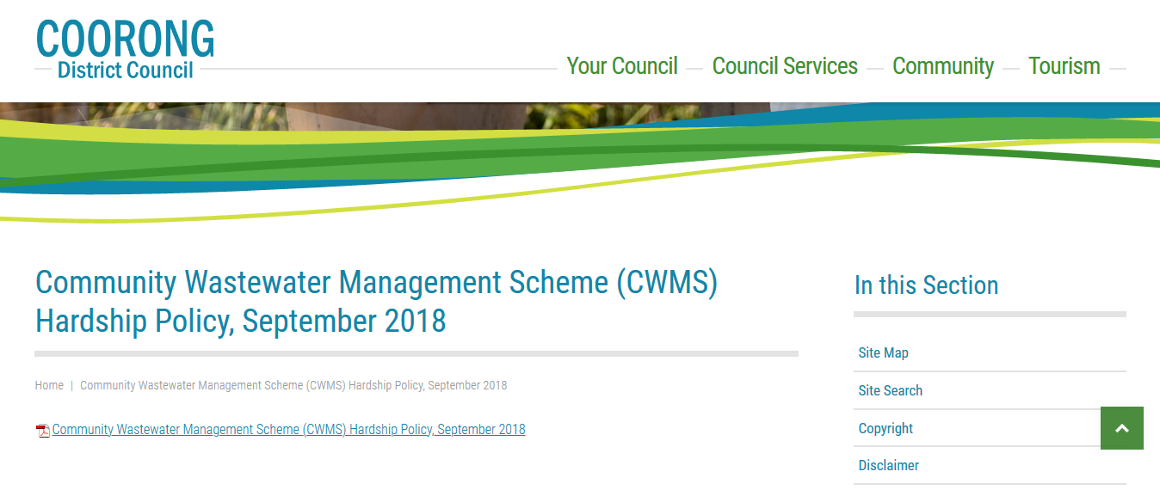
Figure 2. Coorong District Council CWMS Hardship Policy
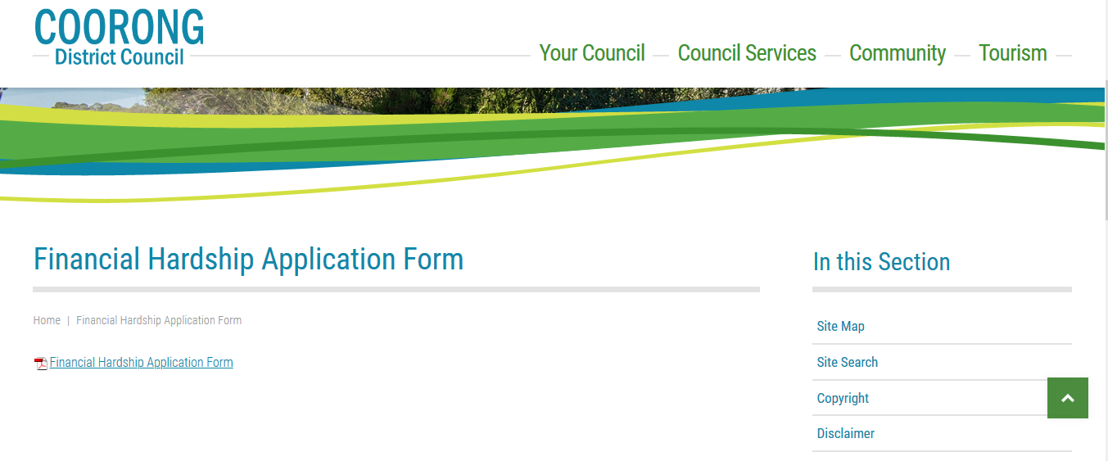
Figure 3. Coorong District Council Financial Hardship Application Form
Activities that were being considered by Council to further enhance the support of customers in financial difficulty and provide them easy access to information about financial counselling services included placing a link on Council’s website’s home page that, posed the question “Are you experiencing financial difficulties?” and then, directed people to information about the Council’s Hardship provisions and Financial Counselling Services. This is yet to be implemented.
City of Playford
The City of Playford is a local government area of South Australia in Adelaide's northern suburbs. The City covers an area of 345 km² and is the fastest growing local government area in South Australia. Population forecasts indicate a growth rate across Playford of nearly 40% from 94,000 in 2018 to more than 130,000 residents by 2039.
Waterproofing Playford is a water-security program that provides water for irrigation across the City of Playford. It includes five wetland sites that collect and treat stormwater, which is stored in underground aquifers and used for irrigation during summer. Retail elements of this program are an important business area for the City.
The City of Playford have taken a very active approach to providing customers with information about their Hardship Policy. Although not specifically targeting water retail customers, the approach is one that could be applied to all customers.
The City’s website ‘Rates’ page includes a section headed “Having difficulty paying rates?” which provides links to the Hardship Policy, FAQ sheet and Hardship Application. (Fig 4)
The City of Playford have also developed a Hardship Tool to support front line staff with their interactions with customers and assessment of a customer’s hardship status. The tool is comprehensive and provides information about financial counselling services, community help referrals, mortgagee contacts, FAQs and staff training sources, as well as including a repayment plan calculator and hardship assessment checklist. (Fig 5.)

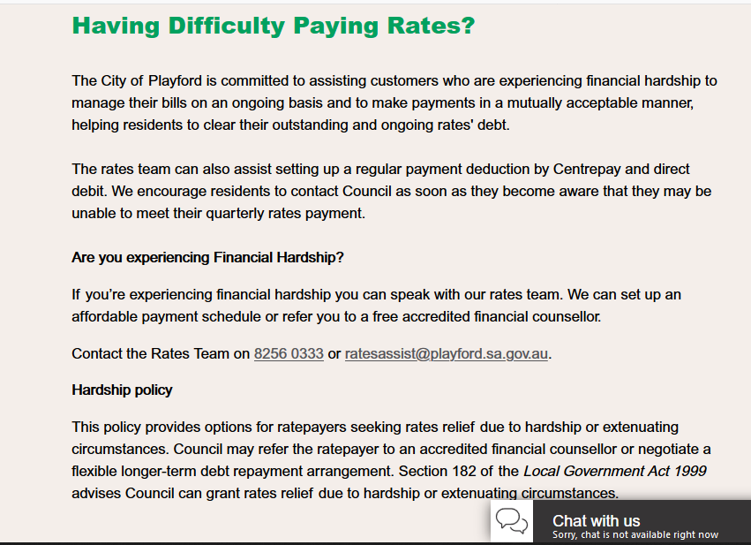
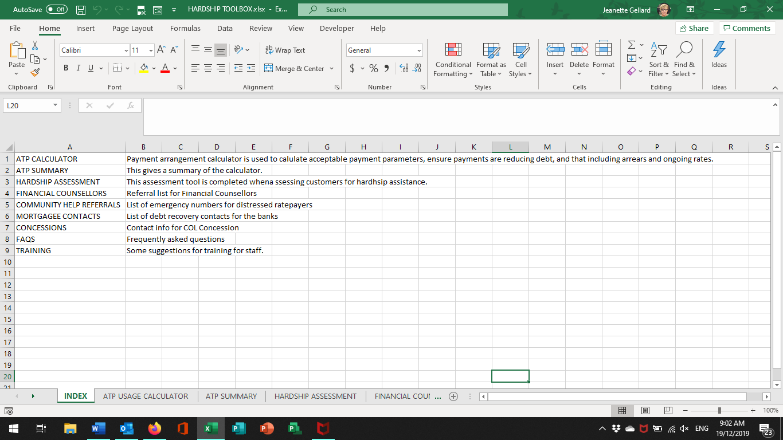
Figure 4. City of Playford Webpage

Figure 5. City of Playford Hardship Tool
Conclusions
The Water Retail Code in place for minor and intermediate retailers requires that providers develop and apply an appropriate Hardship Policy for residential customers experiencing payment difficulty. The way in which service providers integrate and apply the Hardship Policy into their operations varies significantly. There are many examples of actions amongst retailers that collectively demonstrate good practice in this area. The challenge is achieving a consistent approach amongst all retailers. This could be delivered through the application of a foundation suite of tools, collateral and training across the sector.

