Community update

August 2015

This email newsletter is published by the Department of Environment, Water and Natural Resources (DEWNR) to update the community about work being done to secure the future of the Coorong, Lower Lakes and Murray Mouth (CLLMM) region as a healthy, productive and resilient wetland of international importance.

The CLLMM Recovery Project is part of the South Australian Government’s Murray Futures program, funded by the South Australian and Australian Governments.

IN THIS ISSUE

- Coorong winter planting program underway
- First of new barrage fishways nearing completion
- 2014/15 Water quality monitoring
- Lake Albert scoping study update
- Passionate photographer and nature lover? Enter our new competition
- Community Revegetation Program helping local community groups
- Lakes Hub supporting the final year of the CLLMM Recovery Project

Coorong winter planting program underway
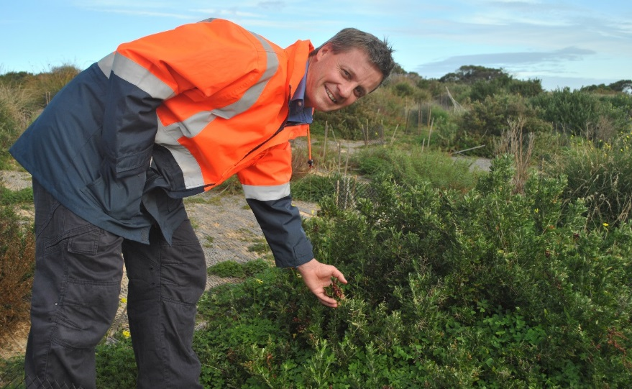
It’s all hands on deck for the annual winter planting season in the Ramsar-listed Coorong, Lower Lakes and Murray Mouth wetland region.
After comprehensive site preparations, planting is now well underway, with more than 700,000 seedlings due to be planted this winter. This will complement a range of other environment, pest control and restoration activities in the region.
DEWNR Vegetation Program coordinator Kym Rumbelow said after many months of preparation, the first seedlings have been delivered to stations in Noonameena and Poltalloch and are now being planted across 18 sites.
James Thiessen, Vegetation Program Senior Project Officer

“Planting will happen over about 20 weeks at sites including Wellington, Meningie and Lake Alexandrina,” Mr Rumbelow said.
“The 20-week-program includes the removal of pest and weed plants such as box thorns and replaces them with native species to improve the health of the region.
“More than 100 different species are being planted, such as sheoak, melaleuca (saltwater paperbark), eucalyptus and banksia seedlings.
“The planting program has been supported by partnerships including with local community organisations. We are also working to restore culturally significant areas by working closely with the local Ngarrindjeri community.
“We’re getting assistance this year from staff from the Natural Resources Adelaide and Mount Lofty Ranges Fire Management Unit. They’ll be helping us distribute plants to planting sites and undertaking pest and weed control works so if you see them out and about say hello!”
To ensure the program’s success, a lot of planning and preparatory work goes on behind the scenes. Some of the tools and processes used to help the program will be shared with the community as the program comes to a close.
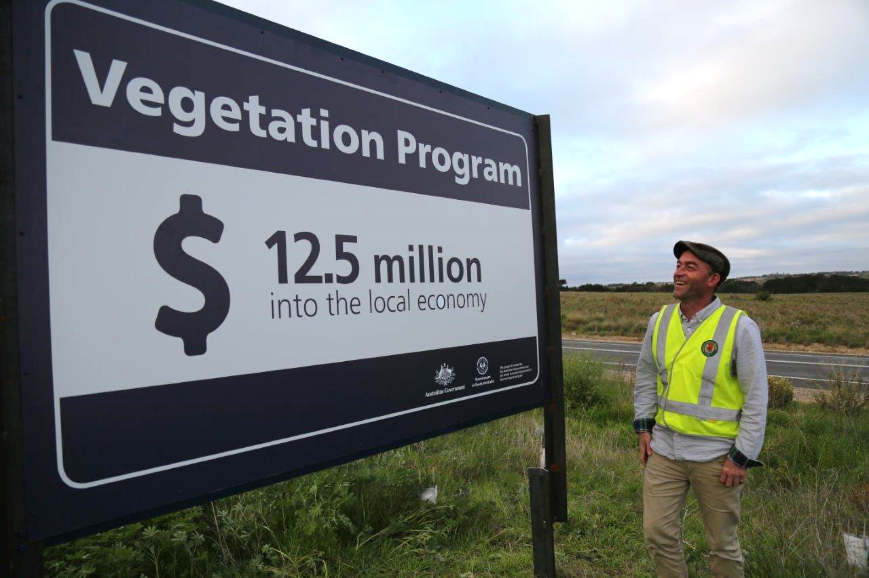
“Our planning and research teams develop site plans, carry out landscape assessments and identify which plants are most suitable for each of the locations to achieve the best outcomes.”
When this year’s winter program is completed, four million seedlings will have been planted on private and public land since the program commenced in 2015. By the end of the Vegetation Program this will total five million plants in the ground.
Chris Gibson, Vegetation Program Senior Project Officer

You may have noticed these stats on some new program signage at one of our most impressive sites at Alexandrina Dairies on the Princes Highway 14 km North of Meningie.
This site was planted in 2014 with more than 100,000 seedlings, and is impossible to miss with its decorated display of tree guards for a two kilometre stretch. The site showcases the efforts of community and project partners over the past four years to improve the condition of the region. This collaboration has seen a massive 75,000 hours of community volunteering invested into the Community Revegetation Project.
Once the winter planting program is complete, preparations for the summer sedge planting program will begin.

First of new barrage fishways nearing completion
Five new fishways are being built at the Lower Murray Barrages at Goolwa, Mundoo Island, Boundary Creek, Ewe Island and Tauwitchere Barrage.
Fishways are structures (also called fish ladders) that allow fish to navigate through locks, dams and other waterway structures. Fishways at the barrages help native fish complete their natural life cycle by moving between the ocean, Coorong and lakes.
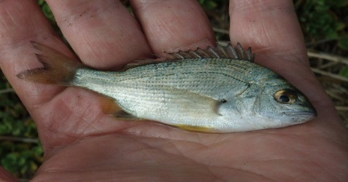
The ‘first cab off the rank’ in the series is being placed at Boundary Creek Barrage, and works there are substantially complete. Although the existing barrage fishways perform effectively, they are located far apart across the combined four kilometres of barrages which does not suit the passage of all fish.
With the variety of fish types present in the Coorong and Lower Lakes, no individual fishway is capable of catering to the needs of all species at once.
A suite of passage options is ideal for the best outcomes. To this end, DEWNR is working with project partners the Murray-Darling Basin Authority and SA Water to build the fishways.
Juvenile Black Bream, DEWNR

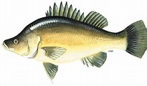
Studies of fish at the barrages indicate that more than 30 native species are likely to swim through them, so there is great potential to create greater habitat connectivity in the site - where fish move freely between the Coorong and Lower Lakes. Direct benefits like greater access to habitat and increased breeding are expected, and indirect benefits are expected too, through increased food supplies for predatory fish.
The positive outcomes from the fishways will extend beyond conservation benefits. The target species of recreational fishers, like Golden Perch and Black Bream will also benefit. Likewise, it is expected that we will see increased sustainability among populations of fish that are significant for the important commercial fishery in the region, which include Mulloway, Coorong Mullet and Greenback Flounder.
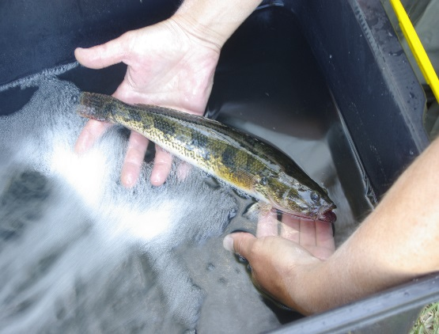
With Boundary Creek well advanced, fishway construction efforts are currently focussed on the Ewe Island barrage. This structure, and one further fishway are anticipated to be in place by Christmas 2015. By this time next year, a further two fishways will see the completion of five new fishways.
At the conclusion of the project the total number of engineered fish passage structures will amount to nine. If savings can be realised, an additional fishway in Tauwitchere Barrage, and more “fish friendly” road crossings along the barrage roadways will also be constructed.
Large Congolli, DEWNR
In creating a series of fishways, this barrage fishways project is contributing to the State goal of maintaining the Coorong, Lower Lakes and Murray Mouth as a healthy and resilient wetland of international importance.
2014/15 Water quality update
Salinity
Salinity in the region displayed some differences compared to the 2013/14 information summarised in the December 2014 Community Update.
Lake Alexandrina average salinity varied less during 2014-15, with an overall average of 636 EC. In comparison with the previous year’s data, a distinct freshening of Lake Albert was evident. The upper survey value for 2014/15 (2335 EC) was below the lowest of average values (2400 EC) listed in 2013/14. The salinity of tributary rivers occupied a similar range to that of Lake Albert, and had an overall average of 1734 EC.
For the Murray Mouth and Coorong North Lagoon, surface salinities varied between 3 parts per thousand (ppt) and 54 ppt. Salinity in the Coorong South Lagoon ranged from 50 ppt to 117 ppt. The upper management target level of 100 ppt was exceeded during April and May 2015, and only at some locations during those months.
Water Quality Targets
Other aspects of the quality of surface water for the region were within target ranges for the health of aquatic ecosystems. This includes levels of oxygen, temperature, pH and nutrients.
Acid sulfate risk
The indicators for sediment acidification (pH, alkalinity and acidity) in the surface waters of the lakes have continued to remain stable and distant from trigger levels.
However, on the shallow groundwater below lake margins the natural recovery processes have not yet reached the point where acidity and metal concentrations fall within the Australian and New Zealand Environment Conservation Council (ANZECC) water quality guidelines.
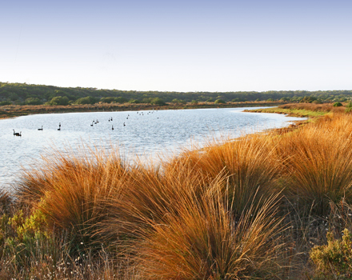
Passionate photographer and nature lover? Enter our new competition
To mark the 30th birthday of the Coorong and Lakes Alexandrina and Albert Wetland being designated a Ramsar site, DEWNR is reaching out to the community to share their love of the site through the power of photos!
We are calling on photo enthusiasts who live, work and play in the Coorong or Lakes Alexandrina and Albert area to help showcase what makes this area unique and special.
The photography competition is all about reflecting on the values and recovery of the site since the 2006-2010 drought. We hope to capture the value and beauty of this unique wetland through the lens of the community.
It’s worth spreading the word with your contacts as there’s a $1000 Diamonds Camera and Video voucher (with a bonus training course valued at $500) up for grabs for the overall winner*.
Prizes will also be awarded to the photographers with the best picture in each of five categories. They’ll take home one of five Canoe, Spirit of the Coorong or National Parks experiences.
The five categories are:
- Our wetland – iconic values, benefits and services
- Wetland habitat and landscapes
- Wetland flora and fauna
- Threats including pests and weeds
- The wetland through time.
For further information contact the Coorong, Lower Lakes and Murray Mouth Recovery Project team or visit the website.
* DEWNR staff are ineligible.
Lake Albert Scoping Study update
You may remember that the Lake Albert Scoping Study was wrapped up at the end of 2014.
The Scoping Study looked into the feasibility of various actions to manage water quality in Lake Albert. As a result of the study the South Australian Government will continue to implement lake cycling when water is available to help manage salinity levels in Lake Albert.
Lake cycling is implemented opportunistically, to make the most of unregulated flow events to raise and then lower and refill water levels to assist the export of salt out of the barrages. Activities such as lake cycling will require optimal weather conditions.
While construction of a channel from the bottom of Lake Albert to the Coorong, also known as a ‘Coorong Connector’, would also result in lower salinity levels, the study concluded it would not achieve this outcome before implementation of lake cycling due to lead-in and construction timeframes.
The study did however result in a recommendation to investigate the potential for a ‘Temporary Reset Pumping’ preventative management option in the event that water levels fall as they did during the 2006-2010 drought.
Three recommendations to the Minister for Water and the River Murray were delivered by the local community and the project’s Community Reference Group following the study’s release.
The project team is happy to advise that a response has been formally provided to the Community Reference Group via their Chair, Mr Neil Shillabeer.
As a result of the community recommendations, DEWNR has made the Cost Benefit Analysis for the project publicly available on its website. You can find the link at the bottom on this web page: http://www.naturalresources.sa.gov.au/samurraydarlingbasin/projects/all-projects-map/lake-albert-scoping-study.

Community Revegetation Program helping local community groups
There are so many good things about the Coorong, Lower Lakes and Murray Mouth (CLLMM) Community Revegetation Program – the restoration of important ecosystems, volunteer involvement, building resilience, and propagation of local native species are a few of them. Another good thing about the project is the support it provides for local community groups.
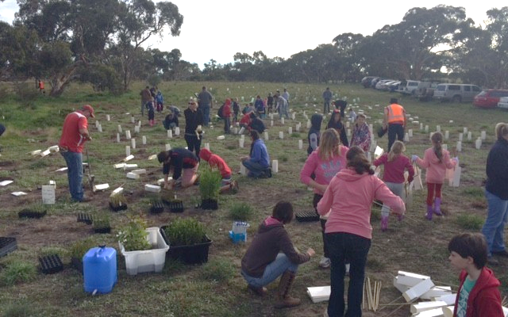
Since 2010, Goolwa to Wellington LAP, through the Community Revegetation Program, has engaged (paid) community groups to propagate and plant approximately 1.2 million local native plants around the Coorong, Lower Lakes and Murray Mouth Region. More than 50 different community groups have been involved in the project, including sports clubs, church groups, disability support organisations, schools, youth groups and more. Volunteers from these groups generally spend a day or more planting seedlings to raise money for their group.
The Strathalbyn Strikers Soccer Club joined the project for the first time this season, with very clear ideas about what they would use the funds they raised for. On the 13th June this year, the club’s catering van was destroyed by fire. The van (“the old girl”) had been used to cater for club members and visiting teams for many years and was the club’s main fundraiser.
The estimated cost of the damage was $20,000. The club is now aiming to raise $40,000 so they can replace the old girl with a proper kitchen.
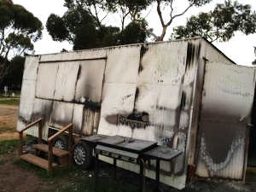
Part of their fundraising program was a planting day with the Coorong and Lower Lakes Community Revegetation Project. About 40 volunteers from the club including a whole bunch of kids spent a Sunday planting nearly 2000 seedlings and earning some much needed dollars to put towards their kitchen. Aside from the joy of raising some money, the group had a great day together out in the bush working together, they learned about the benefits of restoring native vegetation and left with the knowledge that they had done something good for the environment.
You can find out more about the Community Revegetation Project at http://www.gwlap.org.au/.
Lakes Hub supporting the final year of the CLLMM Recovery Project
The Lakes Hub in Meningie and Milang recently received funding of $253,000 to continue their operations under the CLLMM Recovery Project. As the final year of the Recovery Project, the Lakes Hub will play an important role in assisting community to retain and continue much of the fantastic work that has been achieved since 2009.
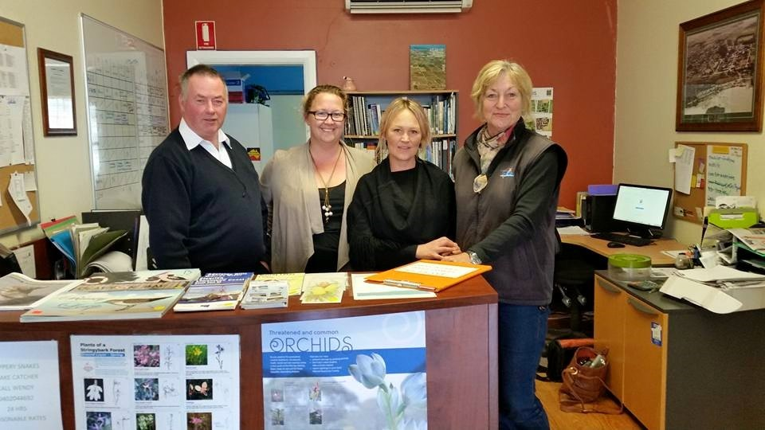
Back then, the Bioremediation and Revegetation Project was a precursor to the drought response CLLMM Recovery Project. The Lakes Hub were established to ensure the participation of local community members and organisations such as those in the Community Nurseries Network, and to facilitate a two-way flow of information between them and government.
The Lakes Hub has evolved with the changing needs of communities in this region and in 2015/16 you will see some changes and some requests for your support and input. Community consultations will be held to help develop a ‘Drought Ready Communities’ Plan. This will involve collecting much of the knowledge that has been built since the commencement of the 2006-2010 drought in the South Eastern Murray-Darling Basin.
Lakes Hub staff at Milang – Glen, Faith, Jo and Carole

“It is empowering to have a local community organisation supporting linkages and connection between the lakes communities and government agencies with the common goal of care for and management of the CLLMM.
“The value of this capacity building supports a healthy and sustainable future for the environment and Coorong and Lakes Communities”, says Karyn Bradford Executive Officer of the Milang and District Community Association Inc.
You can find out more about the Lakes Hub at their website http://lakeshub.com/.

